|  |
| --- |
| Circle Language Spec: Commands |

## Start & Stop in a Diagram

Terms like start and stop were explained in the article *Start & Stop*. The current article displays their symbols.

Each of the following commands or states has a symbol:

Previous

Rollback

Faster Backwards

Slower Backwards

Reverse

Play

Slower

Faster

Go To End

Next

Pause

Wait

Timer

Not Runnable

Stop

Finished

Record

Error

Warning

The symbols are just about the same as those of media players of today:

|  |  |  |  |  |
| --- | --- | --- | --- | --- |
|  |  |  |  |  |
| Previous | Rollback | Faster Backwards | Slower Backwards | Reverse |
|  |  |  |  |  |
|  |  |  |  |  |
| Play | Slower | Faster | Go To End | Next |
|  |  |  |  |  |
|  |  |  |  |  |
| Pause | Wait | Timer | Not Runnable | Stop |
|  |  |  |  |  |
|  |  |  |  |  |
| Finished | Record | Error | Warning |  |

The commands can be displayed at the bottom of the screen to execute a selected command or on a thread, that you are following.

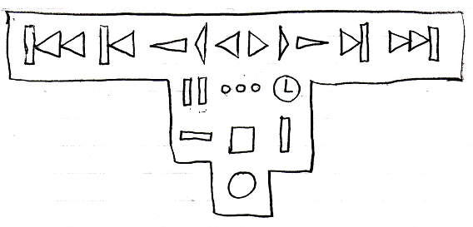

The order of the symbols may become different in practice. They will probably put in a straight line. Some of them can not even be execution *commands*, but can only be execution *states*, so those will be left out of the bottom of the screen.

Another example display of the execution commands and execution states:



The following symbols are also possible candidates:

 

Those symbols could set the speed of going foreward or backward, gradually changing it from Faster Backwards, Reverse, Slower Backwards and to Slower, Play, Faster. The first symbol simply decreases the speed or makes it go faster backwards, and the second symbol simply increases the speed or makes it go slower backwards.

The symbols for actions, that a media player also has, were retained, because I just love symbolic representation and I do not see a need to invent any other symbolic display for this.

An execution state is also be displayed at the bottom of a command symbol, to indicate its state:

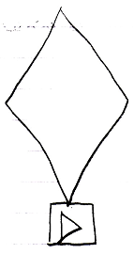

The executable command above is currently running at normal speed, since it is in Play state. Here are more examples of executable command object in different states.

The following command is paused:

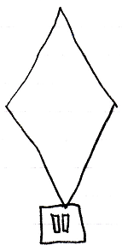

The following command is finished:

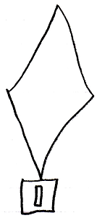

The following command is recording:

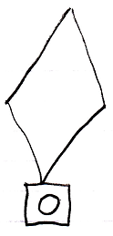

The following command is not executable at all:

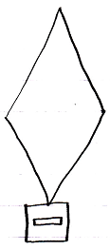

Any execution state can be indicated for a command object like that.